**DML Commands – INSERT, SELECT, UPDATE, DELETE**

**Aim:**

To perform Data Manipulation Language (DML) Commands such as INSERT, SELECT, UPDATE, DELETE in the table

1.Populate all the five tables with your own data.

mysql> insert into student values('191711342','LASYA','F','2005-11-15','1234567890','KOVURU');

mysql> insert into student values('192211068','JASWANTH','M','2004-12-14','1234567980','PUTTUR');

mysql> insert into student values('192211084','VENKAT','M','2004-10-04','1234567089','PUTTUR');

mysql> insert into student values('192211169','PRIYA','F','2005-11-15','1234765089','NELLORE');

mysql> insert into student values('192211123','MAHITH','M','2004-10-17','1274365089','TIRUPATI');

mysql> select* from student;

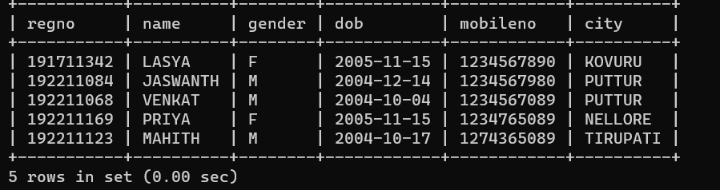

alter table faculty add column(Res char(4));

mysql> insert into faculty values('0010','geetha','F','1973-08-15','1998-01-01','1230987654','01','no');

Query OK, 1 row affected (0.01 sec)

mysql> insert into faculty values('0011','ram','M','1970-04-14','1999-05-10','1230987654','02','no');

Query OK, 1 row affected (0.01 sec)

mysql> insert into faculty values('0013','malini','F','1955-02-02','1998-11-17','1230987654','01','no');

Query OK, 1 row affected (0.01 sec)

mysql> insert into faculty values('0014','rajani','F','1990-05-02','2016-11-17','1230987654','03','yes');

Query OK, 1 row affected (0.01 sec)

mysql> insert into faculty values('0015','siva','M','1990-01-01','2015-09-08','1230987654','04','no');

Query OK, 1 row affected (0.01 sec)

mysql> select* from faculty;

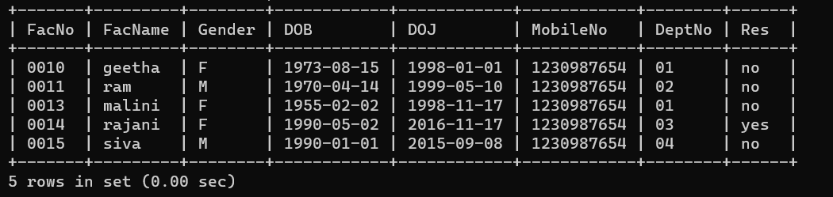

mysql> insert into department values('01','cse','vs');

mysql> insert into department values('02','civil','ms');

mysql> insert into department values('03','mechanical','ga');

mysql> insert into department values('04','ece','hr');

mysql> insert into department values('05','medical','kv');

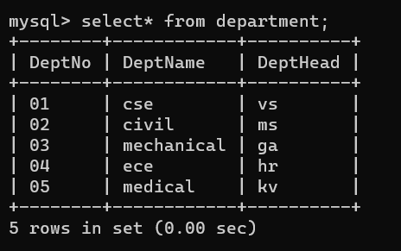

mysql> insert into course values('C01','dbms','M','2','502','3001');

mysql> insert into course values('C02','ethics','E','2','112','3002');

mysql> insert into course values('C03','AI','M','1','412','3003');

mysql> insert into course values('C04','english','M','4','421','3004');

mysql> insert into course values('C04','english','M','4','421','3004');

mysql> insert into course values('C05','C','M','3','321','3005');

mysql> insert into course values('C06','ds','M','2','NULL','3006');

mysql> insert into course values('C07','sql','E','3','NULL','3004');

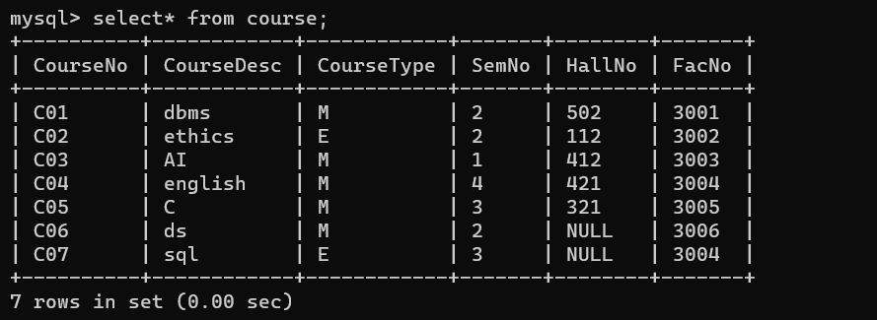

2.Update the value of student name whose register number is ‘191711342’

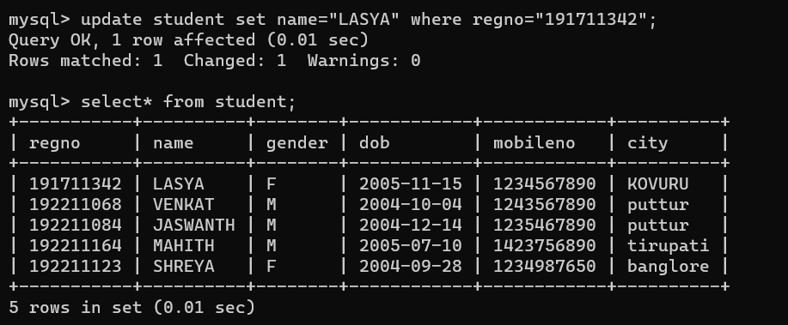

3.Delete the record in the table FACULTY, who resigned her job.

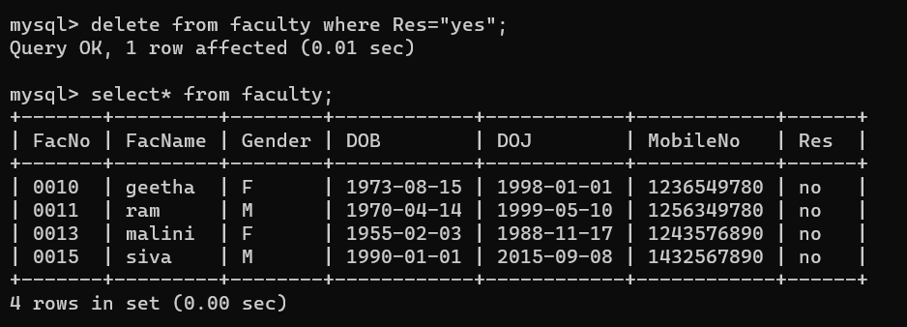

4.Modify the date of birth for the faculty whose name is 'RAM' with a value ‘1983-05-01’.

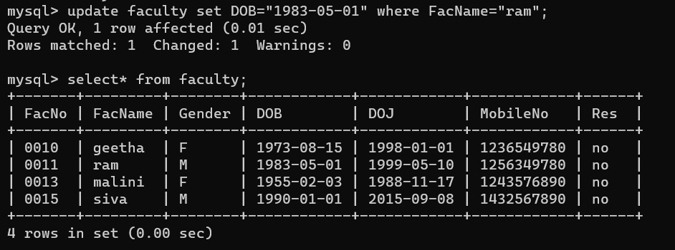

5.Remove all faculty who are having over 65 years.

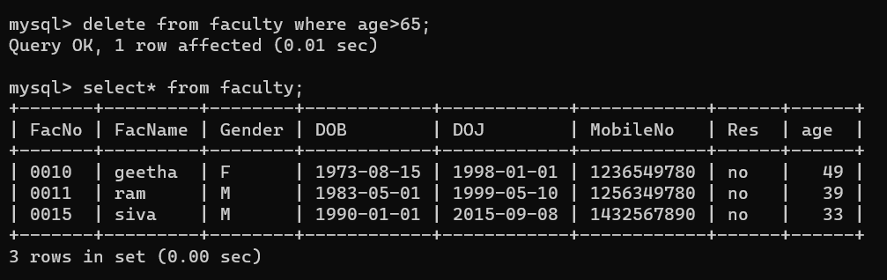

6.View all the records from the five tables. Exercise



